Function line program

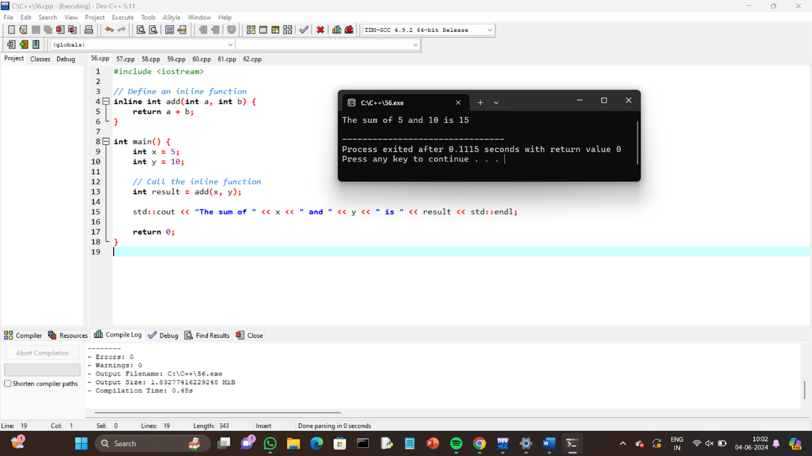

Function Overloading program

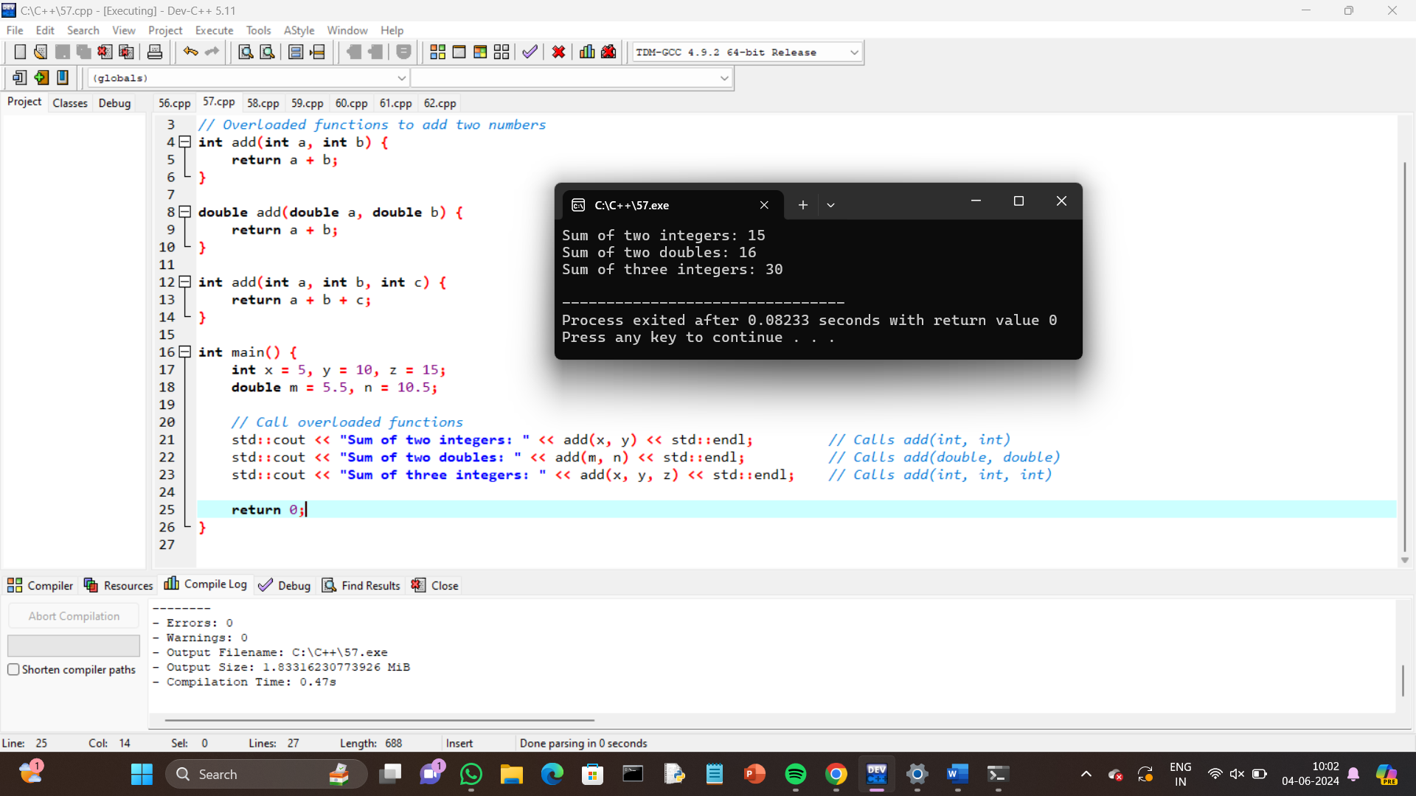

Write a c++ program to create a class for a bank account with a constructor and a destructor

#include <iostream>

#include <string>

class BankAccount {

private:

std::string accountHolderName;

int accountNumber;

double balance;

public:

// Constructor

BankAccount(std::string name, int number, double initialBalance) {

accountHolderName = name;

accountNumber = number;

balance = initialBalance;

std::cout << "Account created for " << accountHolderName << " with account number " << accountNumber << ". Initial balance: $" << balance << std::endl;

}

// Destructor

~BankAccount() {

std::cout << "Account for " << accountHolderName << " with account number " << accountNumber << " is being deleted." << std::endl;

}

// Method to deposit money

void deposit(double amount) {

balance += amount;

std::cout << "Deposited $" << amount << ". New balance: $" << balance << std::endl;

}

// Method to withdraw money

void withdraw(double amount) {

if (amount > balance) {

std::cout << "Insufficient funds. Current balance: $" << balance << std::endl;

} else {

balance -= amount;

std::cout << "Withdrew $" << amount << ". New balance: $" << balance << std::endl;

}

}

// Method to display account information

void displayAccountInfo() const {

std::cout << "Account holder: " << accountHolderName << std::endl;

std::cout << "Account number: " << accountNumber << std::endl;

std::cout << "Balance: $" << balance << std::endl;

}

};

int main() {

// Creating a bank account

BankAccount account("John Doe", 123456, 1000.0);

// Display account information

account.displayAccountInfo();

// Perform some transactions

account.deposit(500.0);

account.withdraw(200.0);

account.withdraw(1500.0);

// Account object goes out of scope here and the destructor is called

return 0;

}

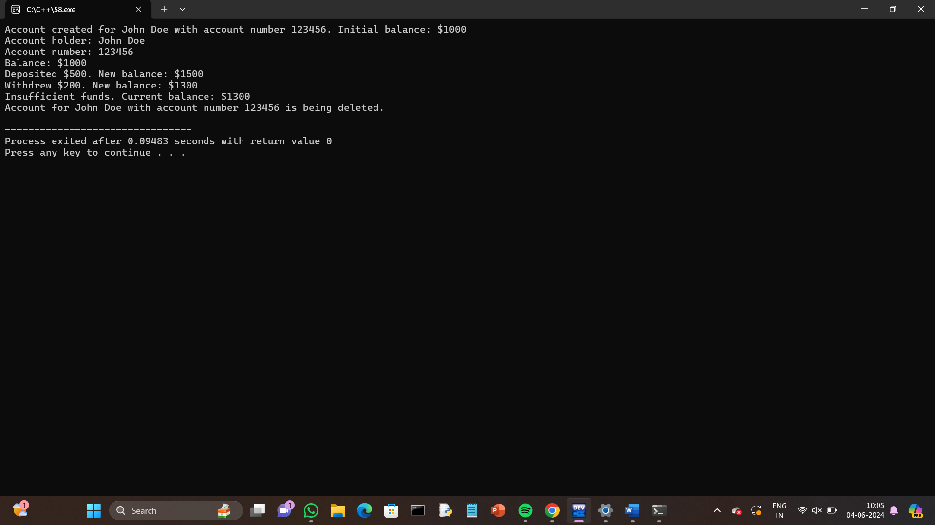

Write a c++ program to create a class for a car with a constructor and a destructor

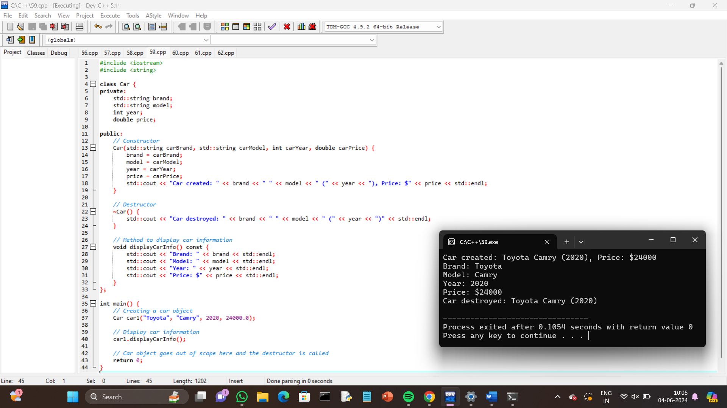

Write a c++ program to create a class for a rectangle with a constructor and a destructor

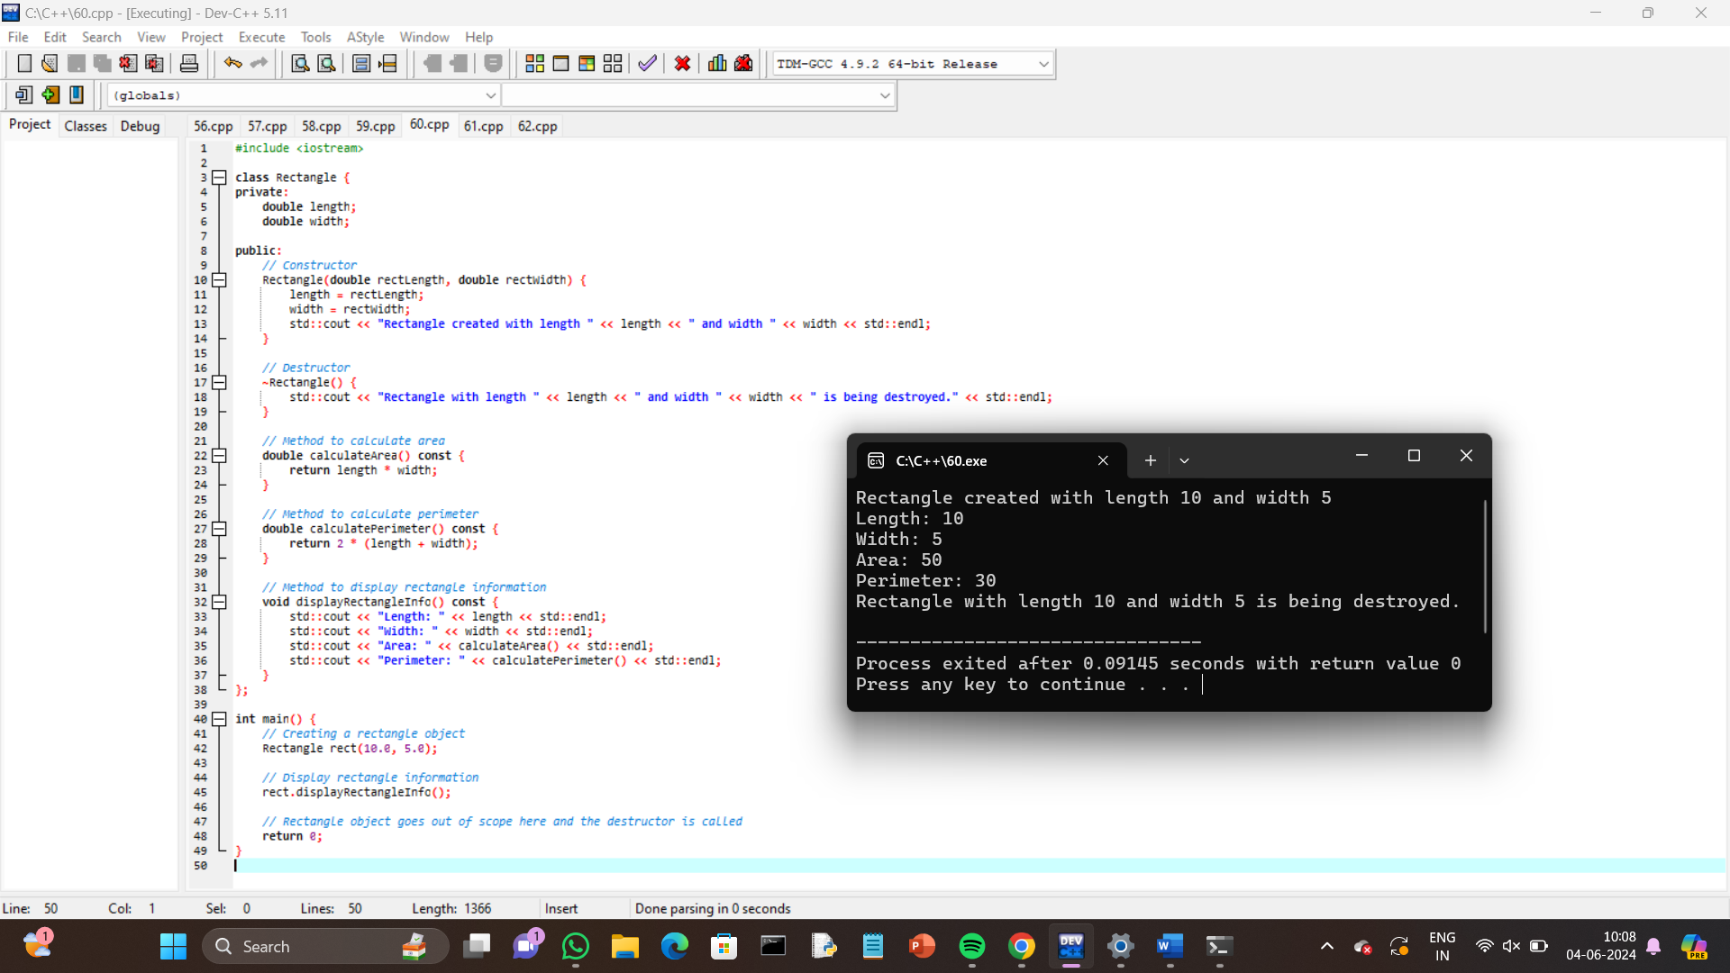

Write a c++ program to create a class for a book with a constructor and a destructor

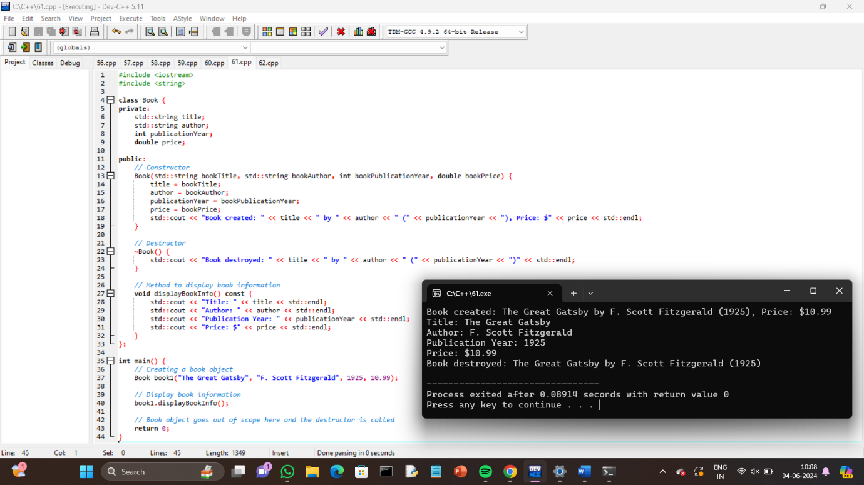

Write a c++ program to create a class for student with a constructor and a destructor

